Boiler Plate

FreshSpoke provides market access to wholesale local food using a set of easy to use web and mobile tools that connect buyer and local food producers. FreshSpoke's innovative shared delivery system takes advantage of excess capacity giving local food producers and other commercial drivers the ability to make extra income delivering local food. FreshSpoke is a platform available for desktop and mobile devices to simplify order, payment and delivery.

Company Description

Igneous Media Inc., a passionate little company based in Barrie, Canada, operates FreshSpoke. FreshSpoke is disrupting the food industry with a collaborative platform that addresses the big challenges of local food distribution and traceability using a shared delivery system that takes advantage of the excess capacity in the transportation system.

It is FreshSpoke’s innovative approach to wholesale local food distribution that earned them the 2017 Ontario Premier’s Award for Agri-Food Innovation Excellence and one of only 10 spots in the Spring 2018 Food-X Cohort.

Product Description

FreshSpoke is a marketing and logistics platform that provides wholesale buyers with a convenient purchase and delivery pipeline to the freshest food from local producers. FreshSpoke's e-commerce enabled platform features a set of simple yet powerful procurement and logistics management tools that simplify order, payment and delivery for buyers and sellers. FreshSpoke's delivery system takes advantage of excess capacity giving commercial drivers and local food producers the ability to make extra cash delivering local food.

FreshSpoke is available in Canada for desktop, iOS and Android devices as well as an API integration. FreshSpoke now operates in select regions of Canada and the United States.

For more information: http://freshspoke.com

General & Media Inquiries:
Marcia Woods, Co-founder | CEO
e. marcia@freshspoke.com
c. 705.717.3442
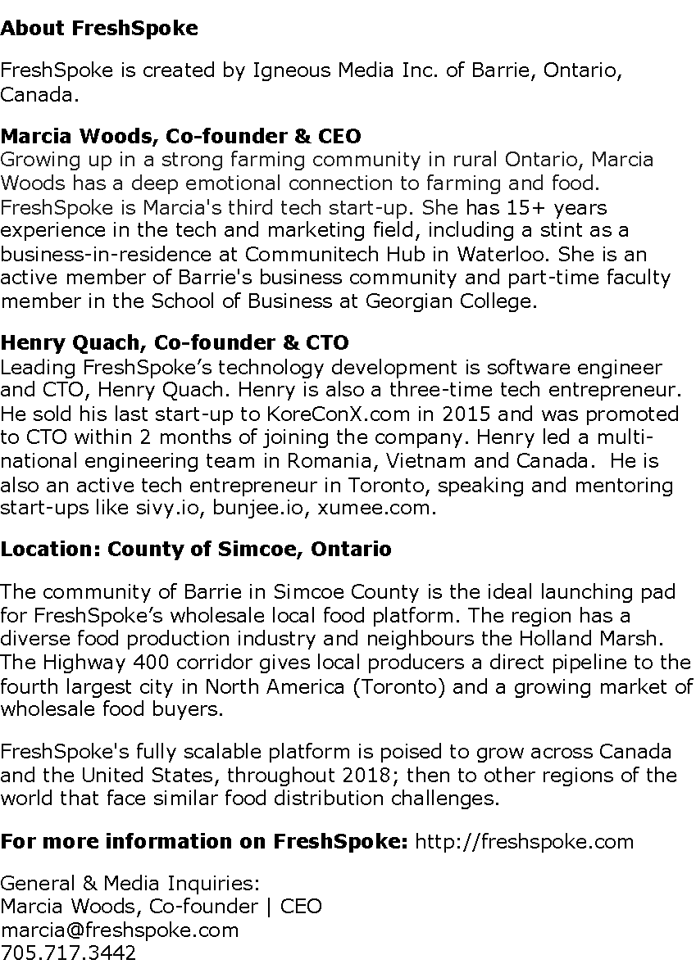

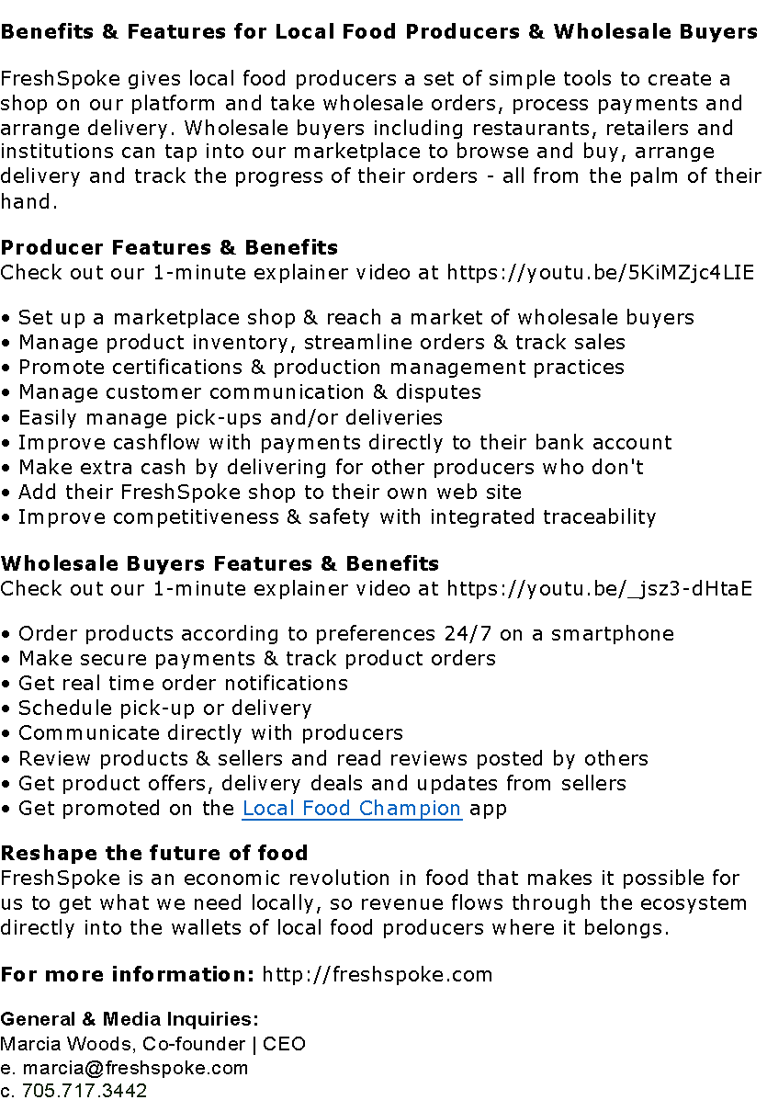

10 Facts about FreshSpoke

What is FreshSpoke?
FreshSpoke is a software platform that tackles the challenge of local food distribution with a set of easy to use tools that simplify order, payment and delivery for wholesale buyers and local food producers.

Why did you create FreshSpoke?
Despite compelling food security research conducted by Deloitte, Metcalf Foundation, Greenbelt Foundation and Rural Ontario Institute, distribution challenges continue to plague the local food system.

Some local food producers have delivery and logistics capacity but most do not. This leaves wholesale buyers with two procurement options: spending precious time self-sourcing or dealing with large scale distributors who offer predominantly imported or factory foods that are often expensive, untraceable and low quality. This globalized food system adds costs, reduces quality and freshness while contributing to the persistent gap between local buyers and sellers that is stunting potential industry growth.

There is considerable growth in year-round availability of local food and a rising demand for traceable, local, sustainably grown foods. Until FreshSpoke there was no easy way to buy or sell local food on a commercial scale.

Who should use FreshSpoke?
FreshSpoke is a business-to-business platform for local food producers that have the capacity to meet the demand of a wholesale market. It is ideal for farmers, artisans, butchers, bakeries, breweries, wineries, distilleries and soft processors.

There is a growing demand for local food amongst restaurants, independent retailers, institutions and other food producers. FreshSpoke offers these buyers the convenience of online order, payment and delivery along with traceability.

What are the benefits for buyers & sellers?
FreshSpoke’s scalable marketplace offers local food producers marketing, distribution and traceability all on one easy to use platform. By connecting a growing crowd of wholesale buyers directly with local food producers, FreshSpoke drives down costs and saves time and resources for buyers and sellers. The addition of shared delivery enables FreshSpoke to scale the platform to encompass producers from across North America, attaining greater efficiency and reducing delivery costs.

FreshSpoke leverages the built-in data and process of Europe’s gold standard of traceability. In doing so, local food producers are prepared and compliant with impending federal food safety track and trace regulations, giving them the ability to compete on par with imports.

For insight on why local food producers have chosen FreshSpoke to grow their wholesale business, check out the producer videos on FreshFlicks.

What does “shared delivery” mean?
FreshSpoke’s shared delivery system called FreshDispatch™, takes full advantage of excess capacity in the delivery system by giving FreshSpoke’s food producers as well as commercial independent and fleet operators (drivers) the ability to make extra income, and reduce operating costs by delivering consolidated local food orders. FreshDispatch™ is paperless with every aspect of the delivery routine from dispatch and routing, to arrival notification and order acceptance and can be entirely handled on the driver’s smartphone.

Who does FreshSpoke consider a local food producer?
“Local” is a moving target and has been the source of much confusion and debate. We like to keep things simple so FreshSpoke qualifies local food producers as those who have a hand in the creation and/or production of a food or beverage with the intention to distribute the product in the same region in which it is created/produced. Does olive oil produced in Italy but bottled in the Ottawa valley qualify as a local food product by our definition? No, but if a producer combines that olive oil with herbs and spices to create a line of dressings, then that producer is welcome on FreshSpoke. In fact, we have a growing roster of popular artisanal products available in our marketplace.

How much does FreshSpoke cost?
Wholesale buyers can use FreshSpoke for free and place unlimited orders from any local food producer in the marketplace. Buyers pay only the cost of the order and delivery (if applicable). Local food producers can set up a shop and access all of our technology tools for free for 30 days. Then, subscribe for one low monthly subscription price as outlined on our pricing page. A fee ranging from 4.9 to 6.9% is charged to the seller on each transaction processed through FreshSpoke.
How do I add my food business to FreshSpoke?
Once you have created a personal account on FreshSpoke’s web or mobile app, you must use our web app to create a shop in the marketplace. For the producers that prefer a DIY approach, FreshSpoke has published a series of how-to videos in our Help Centre. For producers who need help, FreshSpoke has a team of Customer Activation Specialists experienced and ready to assist with photography, videography and content development.

How do I get FreshSpoke?
Simply go to the FreshSpoke website or download FreshSpoke from Google Play or iTunes. Then, sign up on the app or connect using a facebook or twitter account.

What geographic area does FreshSpoke cover?
FreshSpoke launched in Simcoe and Grey Counties in Ontario in September 2016 and is now expanding across Canada and the United States.

For more information on FreshSpoke, http://freshspoke.com

General & Media Inquiries:
Marcia Woods, Co-founder | CEO
e. marcia@freshspoke.com
c. 705.717.3442

